Eremit Instructions
Please note the appearance of the website may vary slightly depending on the browser being used.
Login to Eremit using provided credentials and reset password if prompted to do so.
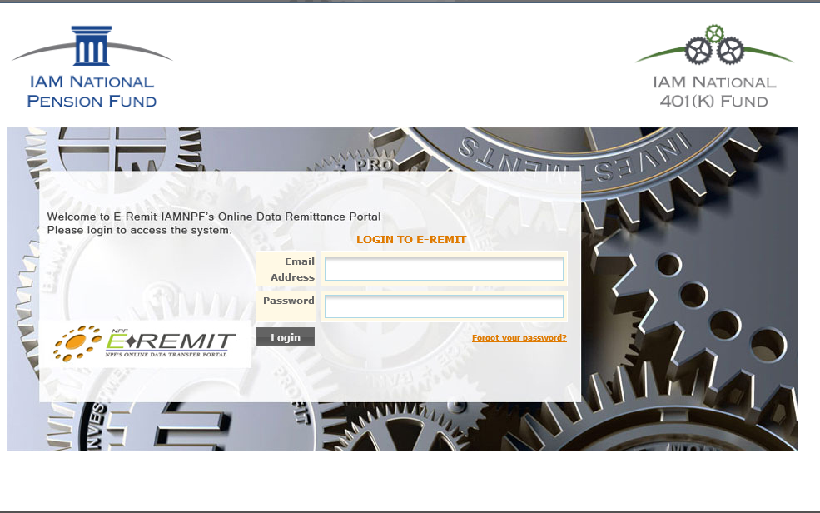

Click Back To Eremit at lower left.
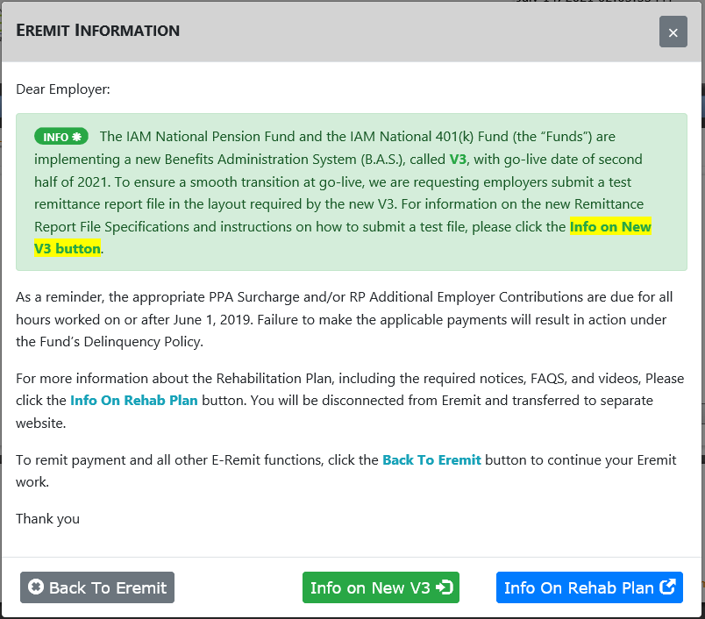

Choose the appropriate file format from Downloads in the blue menu bar.
Complete the file. There are FAQ’s available in the Help Center to assist with file preparation.
Check the appropriate boxes/circles according to the type of file being submitted.
Click Next in the lower right.

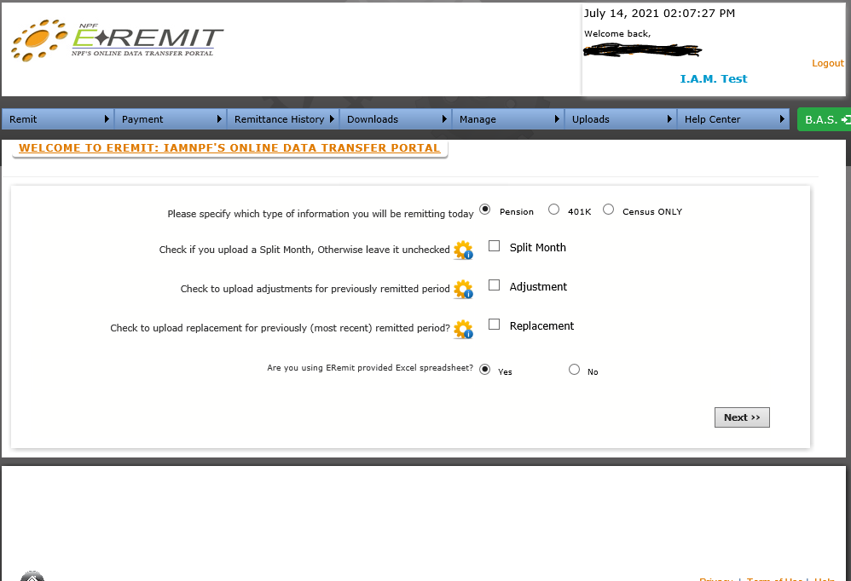

If Pension file is being transmitted the screen below will appear.
The calculator is optional but recommended to verify the entries in the file are correct.
Click Choose File.
Browse to the location the file has been saved to and select it.
Click Next in the lower right.
If there are no error’s click Complete Upload now to receive confirmation of completed transmission.
If the system return’s error message make necessary corrections and reattempt the upload.
After confirmation click Pay Now if you wish to pay by ACH or click Transmittal if paying by check.
Clicking Transmittal will produce a printable form to send with your payment.
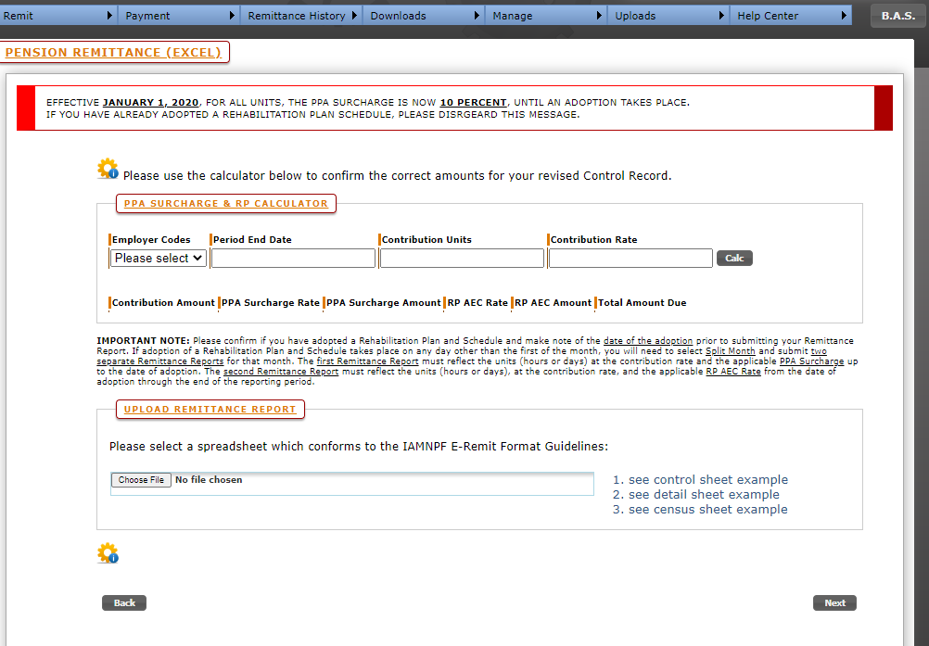

If 401-k file is being transmitted the screen below will be shown.
Follow the instructions above (excluding the optional calculator) to complete upload and continue to payment.
